DIOCESE OF PITTSBURGH  SECRETARIAT FOR EVANGELIZATION AND  CATHOLIC EDUCATION | www.diopitt.org | 2900 Noblestown Road  Pittsburgh, PA 15205  Schools: (412) 456-3090  e-mail: Schools@diopitt.org  OR Religious Education: (412) 456-3112  e-mail: ReligiousEducation@diopitt.org

Catholic School Students, Religious Education Students . . .
The Face of Christ in Chimbote!

Department for Catholic Education
Chimbote Mission Donation Report Form

School or Parish Name: ______________________________________ Location Number: ___________ Date _____________
Amount of Donation: $____________

Please describe the nature of your Chimbote Project from which these funds
were collected:

Check one and sign, please:
[ ] Principal or [ ] DRE Signature_____________________________

Please complete this form, and send it with your donation check by June 1 to: [more info at www.diopitt.org/Chimbote (412) 456-3085]

The Chimbote Foundation
Catholic Diocese of Pittsburgh
2900 Noblestown Road
Pittsburgh, PA 15205

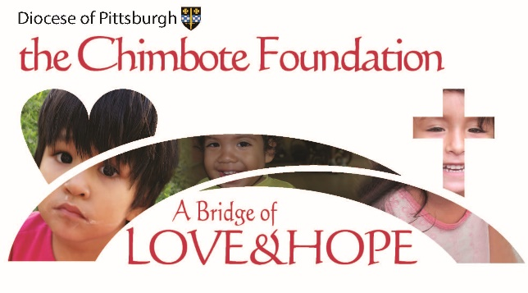 Muchas Gracias!

